**MODULE 3: FORECASTING**

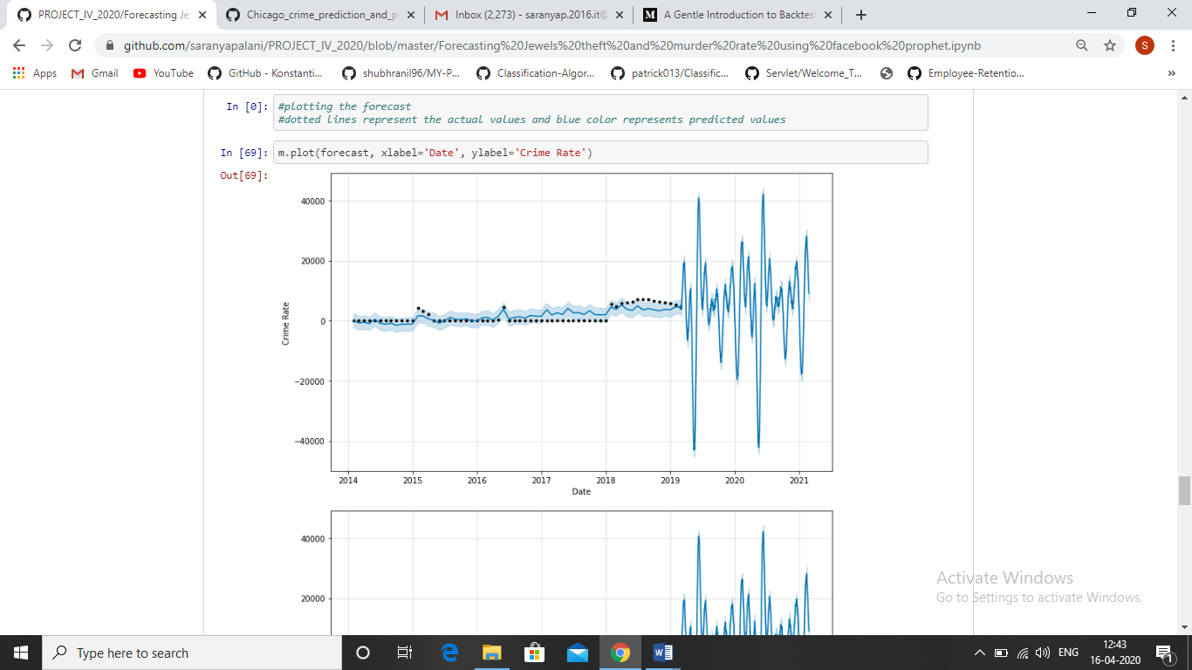

Figure 4